1.**Print 1d and 2d array by taking the elements from the user.**

1D Array:

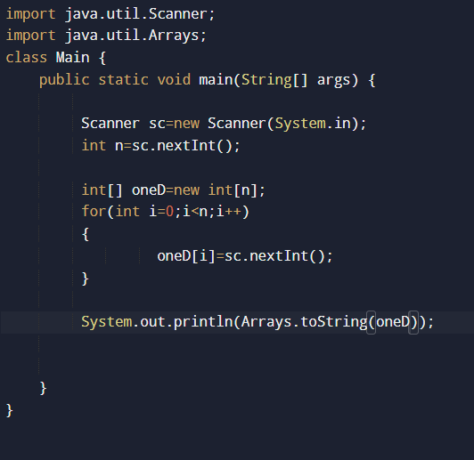

2D Array:  
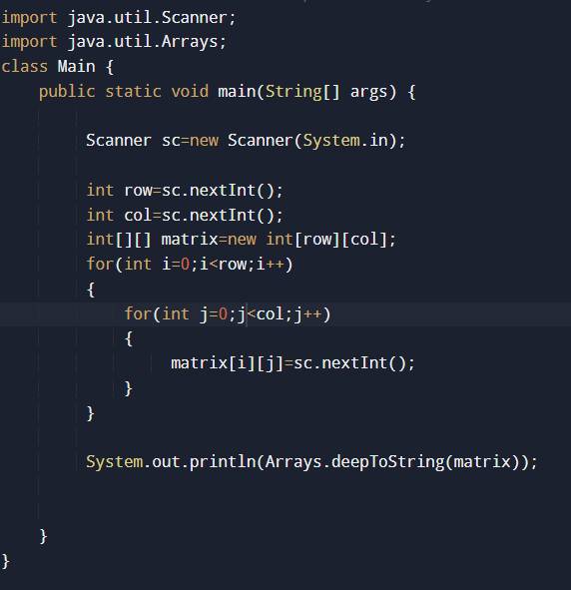

2**.Print one dimensional array using do- while**

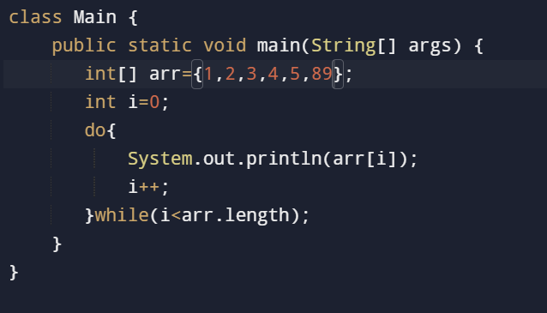

**3. Print 2D(2 DImensional Array) using Do while.**

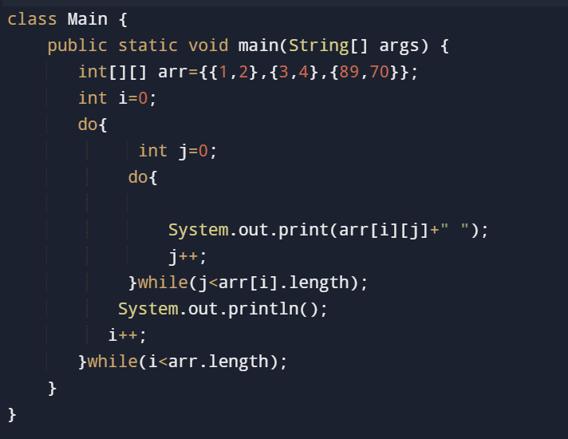

**Home work:**

**4. Print the element of 1D array using recursion Method**

**5. Print the element of 2D array using recursion Method**